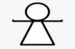
Private primary school: TANIT School School year: 2020-2021
Teacher: Amel Ochi English Exam N°1 Time: 1 hour
2nd Form

Name: ......................................... Surname: ................................................ Score: /10

1- Circle the right answer: (1 mark)
- Miss Jones is a (pupil - girl - teacher).
- (Red - pencil case - fifteen) is my favourite colour.
- The boy is (ten - pen - happy).
- The pupil is sitting on the (desk - chair - table).
2- Match the questions with the answers: (1,5 marks)
-How are you? | Dog.
-What is your favourite animal? | It is a ruler.
-What is it? | I'm fine, thank you.

3- Label the pictures: (2 marks)
Board - Listen - sing a song - Classroom

........................ | ......................... | ....................... | .......................

4- Reorder the words to make correct sentences: (1 mark)

- name / is / My / Rosy.

My.................................
- a / is / It / rubber.
It....................................
5-Choose words from the list then write: (2 marks)
- ................... close
- My ................ is Jane, this is my ....................... name
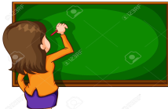
It is yellow and ...................... orange
- The teacher is .................. on the board. school bag
- This is my new........................ , it is .................. pink
- Can you .................. the door, please? writing
car
hello

6- Replace the underlined words with: he, she, it, they (1,5 marks)
- The crayons are on the desk. - My school bag is new.
.............. ................
- Mr. Ahmed is absent today. - Dogs are faithful.
.............. ................
- Miss Austen and miss Jane are teachers. - The girl is beautiful.
............. ................

7- Fill in the missing letter: (1 mark)
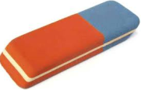
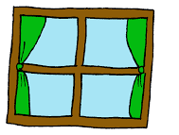

---ook win---ow te--- ---ubber
(o - u - b) (d - o - w) (t - u - n) (e - m - r)
Best of luck

