1^{ére} A Activités Numériques 2 Mr Ziadi Mohamed

Exercice 1
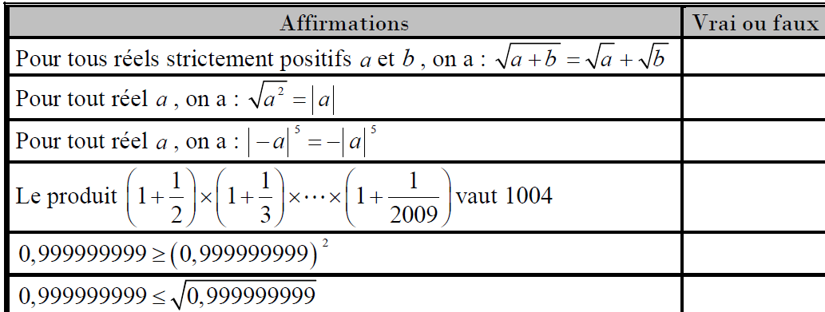
Exercice 2
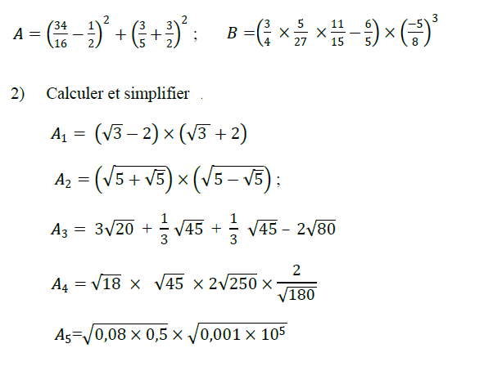
Exercice3
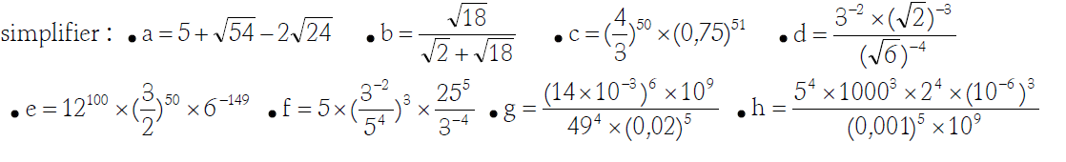
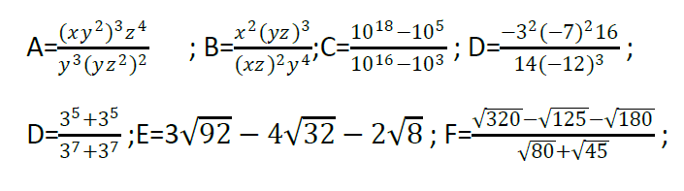
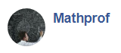https://www.facebook.com/groups/277073623630286/ Tel :58 047 062

Exercice4
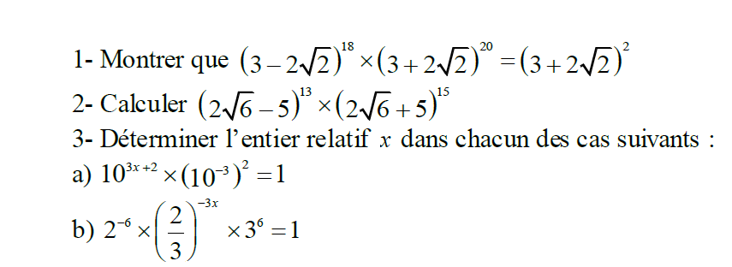
Exercice 5
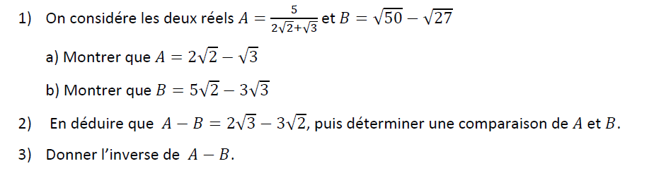
Exercice 6
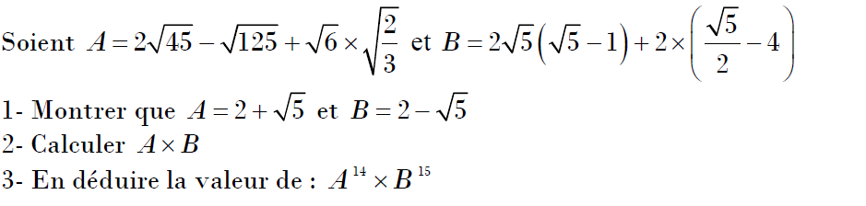
Exercice 7
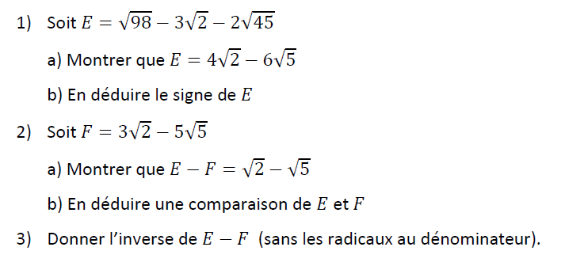
https://www.facebook.com/groups/277073623630286/ Tel :58 047 062

Exercice 8
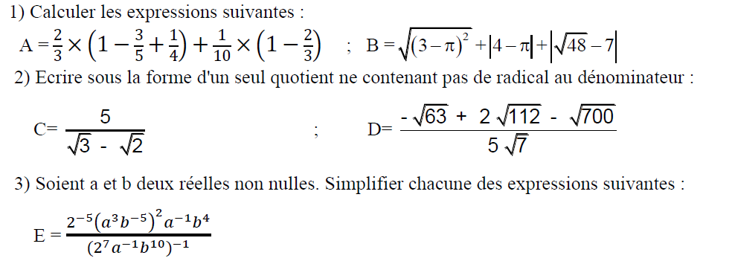
Exercice 9
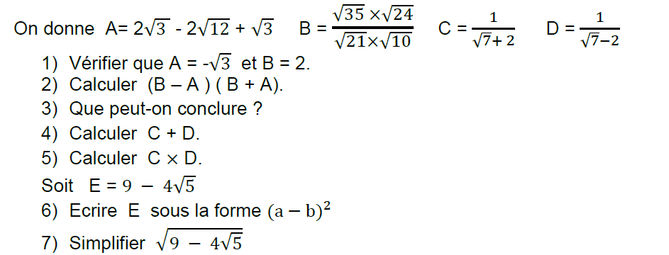
Exercice 10
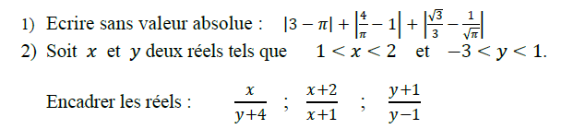
Exercice 11
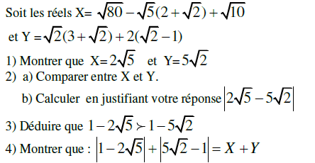
https://www.facebook.com/groups/277073623630286/ Tel :58 047 062

Exercice 12
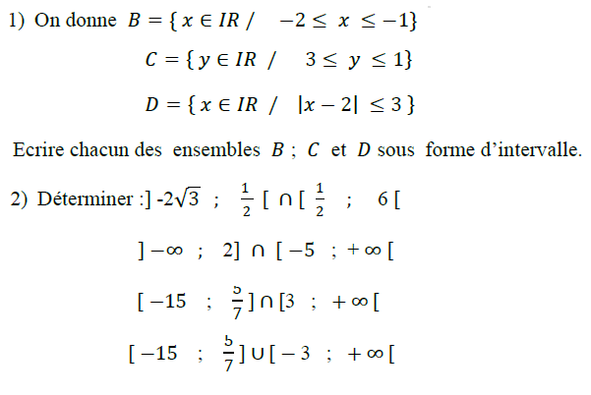
Exercice 13

https://www.facebook.com/groups/277073623630286/ Tel :58 047 062

